**Software Developer: Zakia Salod**

KRISP  Nelson R. Mandela Medical School, 719 Umbilo Road, Umbilo, Durban, 4001

Use Case Acceptance Criteria



**Use Case Acceptance Criteria**

**Project Name: KRISP: The Matrix Illustration Algorithm**

**Project Manager: Prof Tulio de Oliveira**

# Revision History

| **Version** | **Date** | **Revision Description** |
| --- | --- | --- |
| 1.0 | 15 June 2019 | Approved Document |
|  |  |  |
|  |  |  |
|  |  |  |
|  |  |  |
|  |  |  |
|  |  |  |

# Table of Contents

Revision History 2

Table of Contents 3

Glossary 5

Overview 6

Scenarios 7

Scenario #SC1 7

Acceptance Criteria #AC1 7

Scenario #SC2 8

Acceptance Criteria #AC2 8

Scenario #SC3 9

Acceptance Criteria #AC3 9

Scenario #SC4 10

Acceptance Criteria #AC4 10

Scenario #SC5 11

Acceptance Criteria #AC5 11

Scenario #SC6 12

Acceptance Criteria #AC6 12

Scenario #SC7 13

Acceptance Criteria #AC7 13

Scenario #SC8 14

Acceptance Criteria #AC8 14

Scenario #SC9 15

Acceptance Criteria #AC9 15

Approvals 16

Appendix 17

**Figure 1. Matrix pattern algorithm A)** 7

**Figure 2. Matrix pattern algorithm B)** 8

**Figure 3. Matrix pattern algorithm C)** 9

**Figure 4. Matrix pattern algorithm D)** 10

**Figure 5. Matrix pattern algorithm E)** 11

**Figure 6. Matrix pattern algorithm F)** 12

**Figure 7. Matrix pattern algorithm G)** 13

**Figure 8. Matrix pattern algorithm H)** 14

**Figure 9. Matrix pattern algorithm I)** 15

# Glossary

List definitions of any terms with which someone unfamiliar with the project or industry may not be familiar. Include both IT and business-side terms.

| **Term** | **Definition** |
| --- | --- |
| Algorithm | In Mathematics and in Computing, an algorithm is a set of instructions or rules for solving a particular problem. Most notably, these are performed by a computer. |
| Matrix | In Mathematics and in Computing, a matrix is a rectangle array or display of numbers or symbols lay out in rows and columns. If a matrix has, for example, 5 rows and 5 columns, the matrix is said to have 5 by 5 dimension and of size 5. |

# Overview

Construct a generic algorithm for a 5x5 square matrix with size odd, completed as shown below (refer to each scenario below). Note that the example is for a 5x5 square matrix (assuming the user enters 5 as the size of the matrix)

Rules:

1. If you change the size of the matrix, the answers should remain identical to the illustrations in the A-I questions below.
2. They should be printed in the way they are illustrated, with only characters 1 to 5 being allowed for the matrix numbers and blank space.
3. try to build with as few lines as possible.
4. Use the programming language of your choice, but the algorithm should work in any programming language if you change the syntax of the loop (for, while) and if-else

# Scenarios

Repeat the following sections for multiple user stories.

## Scenario #SC1

When a user enters an odd whole number, then the matrix should print as per Figure 1 below.

## Acceptance Criteria #AC1

Populate table with the acceptance criteria for the scenario.

|  |  |
| --- | --- |
| **Given** (an initial condition) | That the user accesses the KRISP matrix illustration algorithm. |
| **When** (something happens) | The user enters an odd whole number as input into the algorithm. |
| **Then** (this is the result) | The matrix should display as illustrated in Figure 1 below, for matrix pattern algorithm A). |

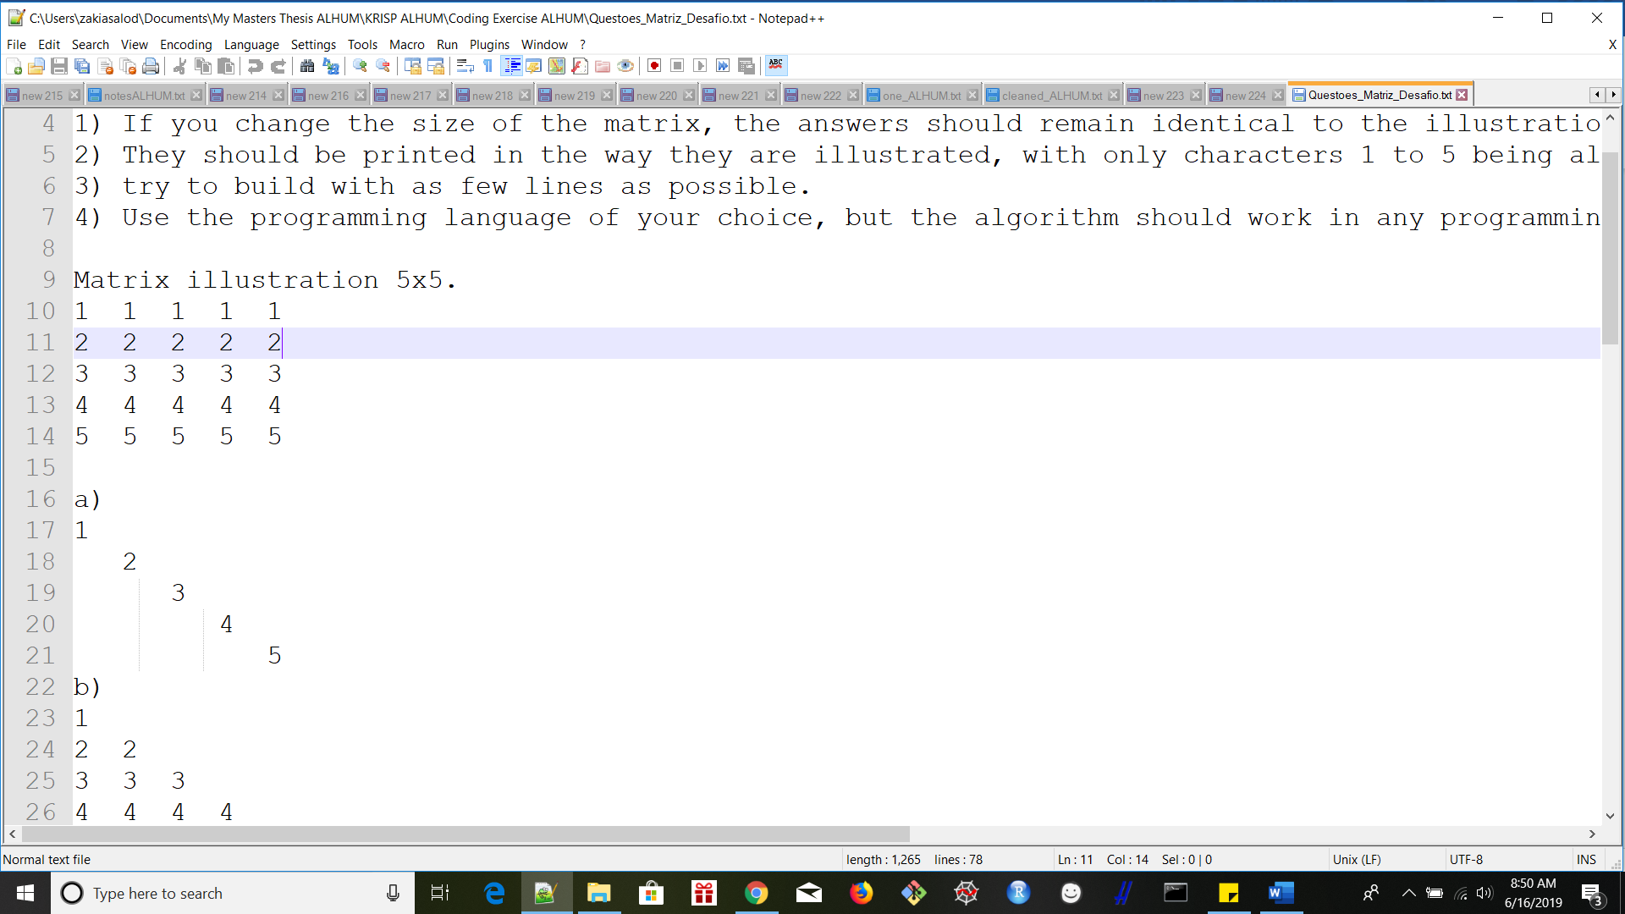

**Figure 1. Matrix pattern algorithm A)**

## Scenario #SC2

When a user enters an odd whole number, then the matrix should print as per Figure 2 below.

## Acceptance Criteria #AC2

Populate table with the acceptance criteria for the scenario.

|  |  |
| --- | --- |
| **Given** (an initial condition) | That the user accesses the KRISP matrix illustration algorithm. |
| **When** (something happens) | The user enters an odd whole number as input into the algorithm. |
| **Then** (this is the result) | The matrix should display as illustrated in Figure 2 below, for matrix pattern algorithm B). |

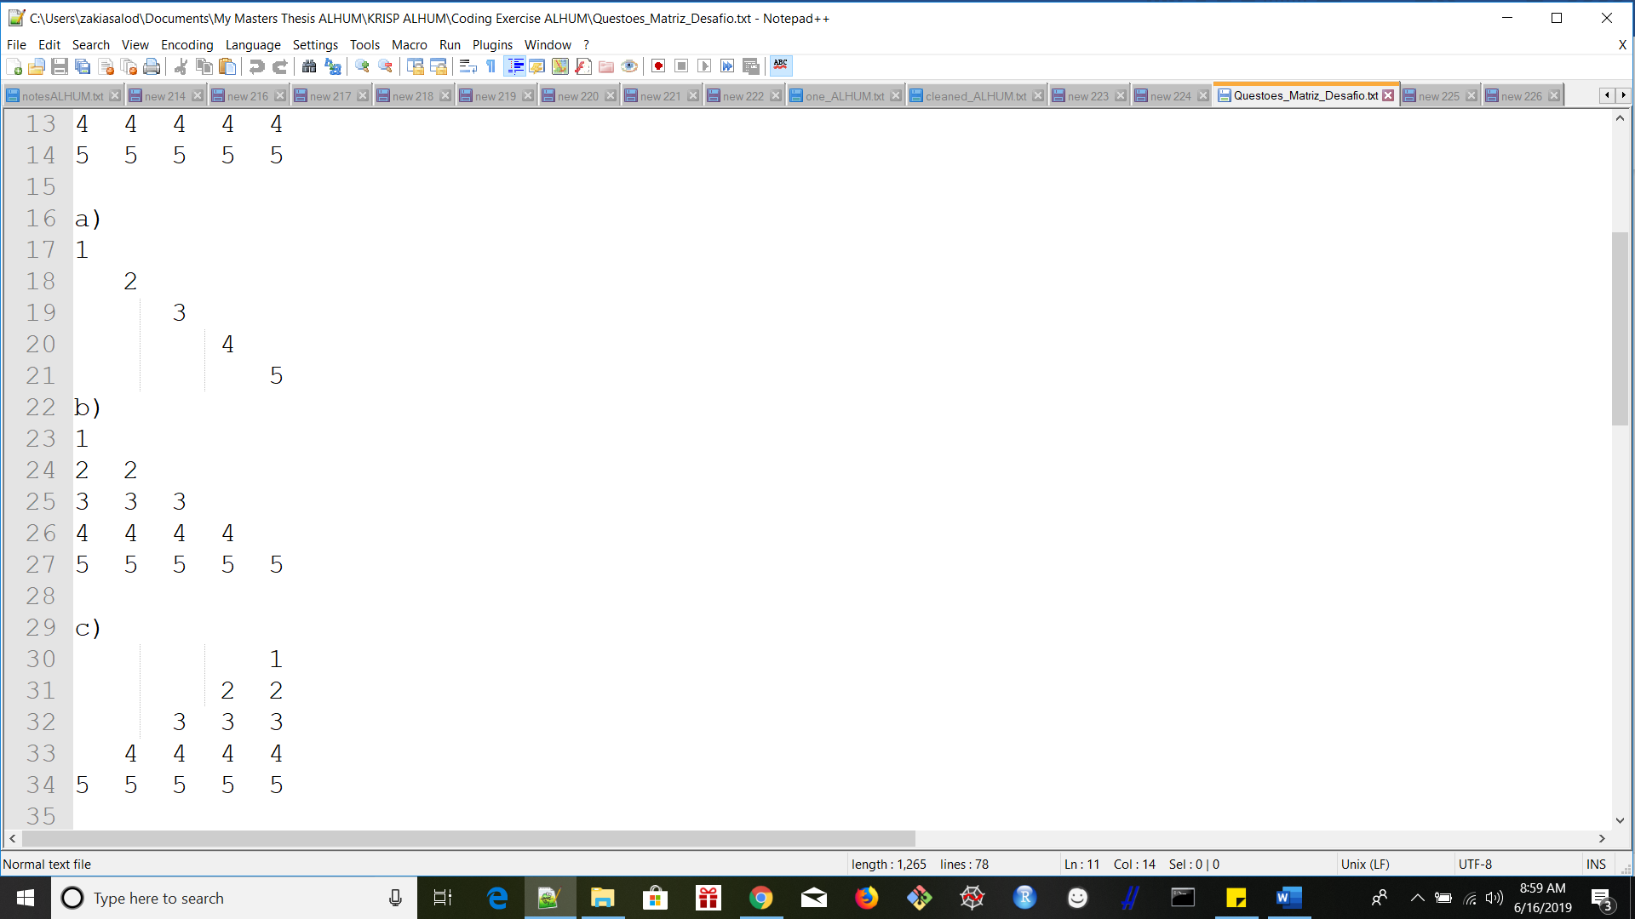

**Figure 2. Matrix pattern algorithm B)**

## Scenario #SC3

When a user enters an odd whole number, then the matrix should print as per Figure 3 below.

## Acceptance Criteria #AC3

Populate table with the acceptance criteria for the scenario.

|  |  |
| --- | --- |
| **Given** (an initial condition) | That the user accesses the KRISP matrix illustration algorithm. |
| **When** (something happens) | The user enters an odd whole number as input into the algorithm. |
| **Then** (this is the result) | The matrix should display as illustrated in Figure 3 below, for matrix pattern algorithm C). |

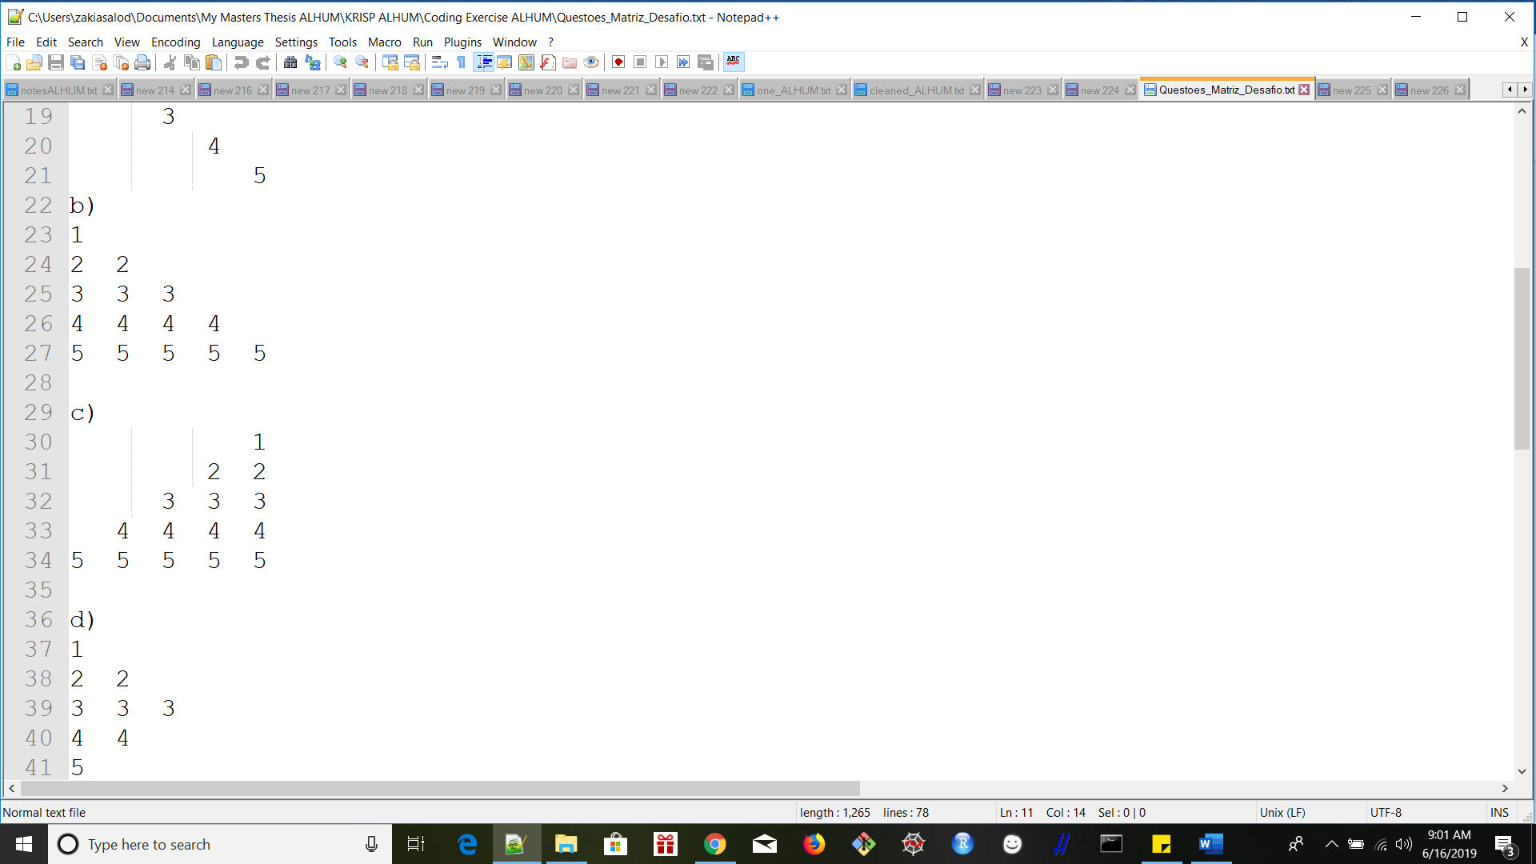

**Figure 3. Matrix pattern algorithm C)**

## Scenario #SC4

When a user enters an odd whole number, then the matrix should print as per Figure 4 below.

## Acceptance Criteria #AC4

Populate table with the acceptance criteria for the scenario.

|  |  |
| --- | --- |
| **Given** (an initial condition) | That the user accesses the KRISP matrix illustration algorithm. |
| **When** (something happens) | The user enters an odd whole number as input into the algorithm. |
| **Then** (this is the result) | The matrix should display as illustrated in Figure 4 below, for matrix pattern algorithm D). |

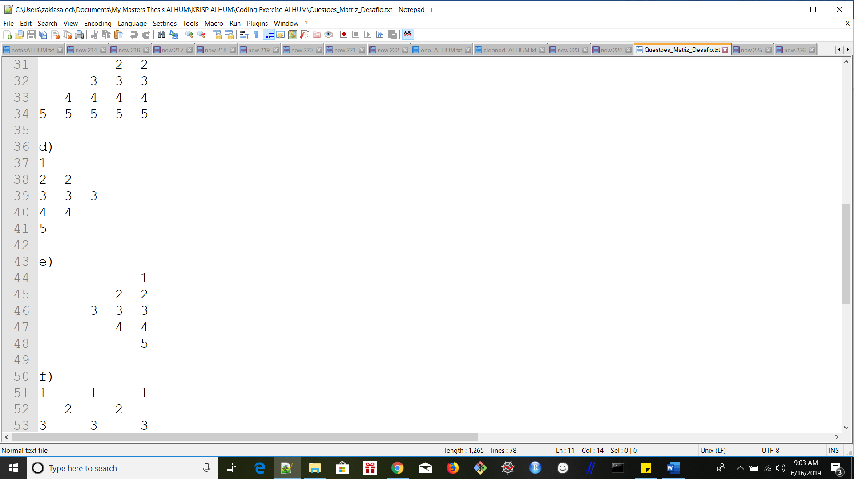

**Figure 4. Matrix pattern algorithm D)**

## Scenario #SC5

When a user enters an odd whole number, then the matrix should print as per Figure 5 below.

## Acceptance Criteria #AC5

Populate table with the acceptance criteria for the scenario.

|  |  |
| --- | --- |
| **Given** (an initial condition) | That the user accesses the KRISP matrix illustration algorithm. |
| **When** (something happens) | The user enters an odd whole number as input into the algorithm. |
| **Then** (this is the result) | The matrix should display as illustrated in Figure 5 below, for matrix pattern algorithm E). |

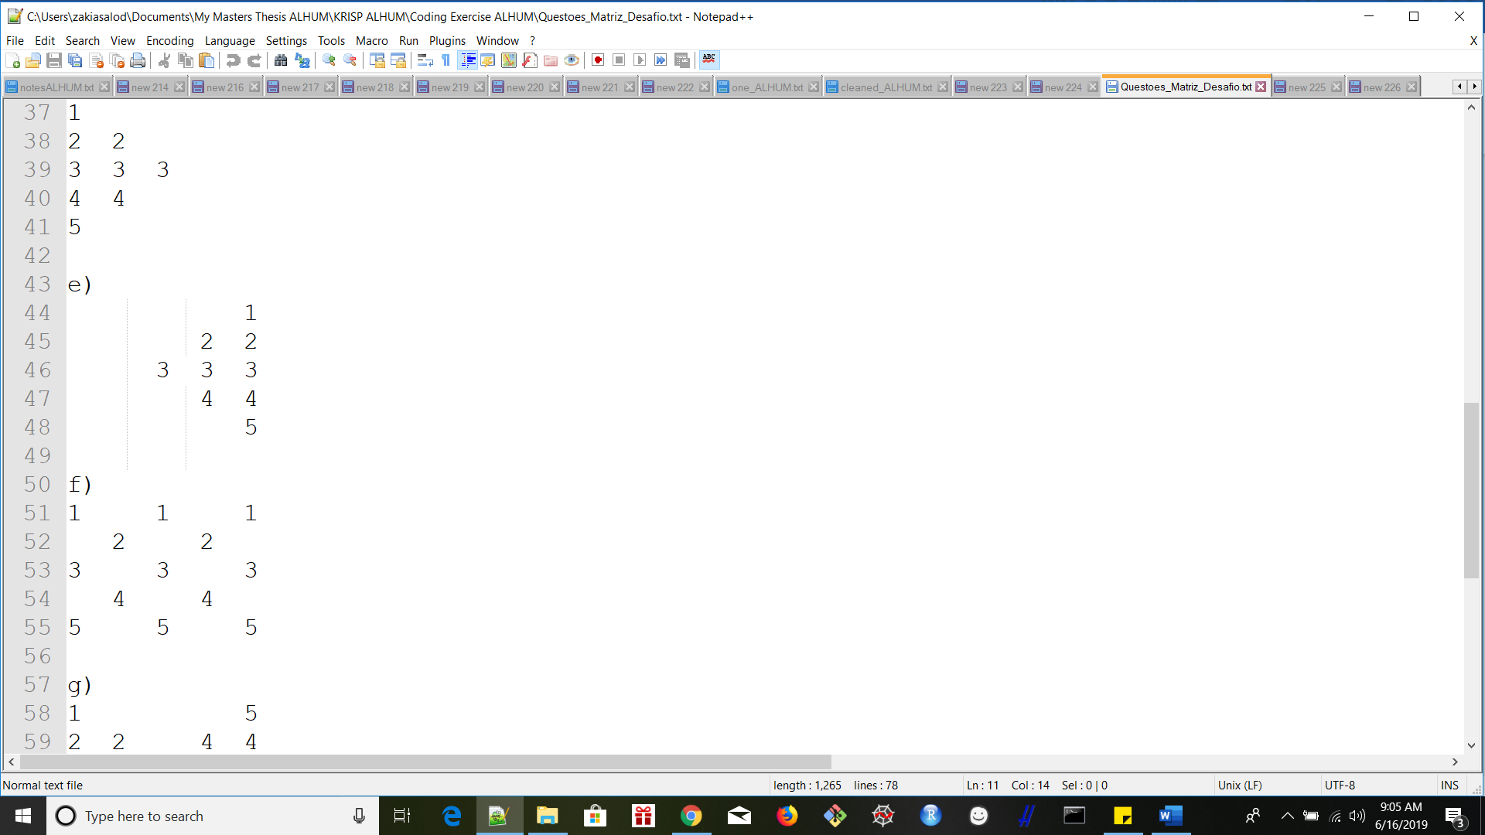

**Figure 5. Matrix pattern algorithm E)**

## Scenario #SC6

When a user enters an odd whole number, then the matrix should print as per Figure 6 below.

## Acceptance Criteria #AC6

Populate table with the acceptance criteria for the scenario.

|  |  |
| --- | --- |
| **Given** (an initial condition) | That the user accesses the KRISP matrix illustration algorithm. |
| **When** (something happens) | The user enters an odd whole number as input into the algorithm. |
| **Then** (this is the result) | The matrix should display as illustrated in Figure 6 below, for matrix pattern algorithm F). |

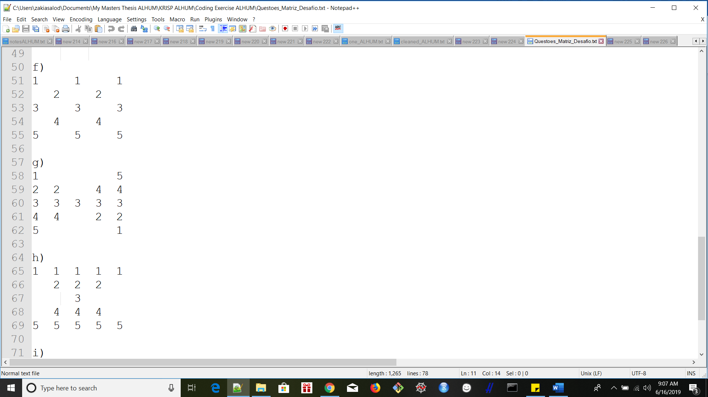

**Figure 6. Matrix pattern algorithm F)**

## Scenario #SC7

When a user enters an odd whole number, then the matrix should print as per Figure 7 below.

## Acceptance Criteria #AC7

Populate table with the acceptance criteria for the scenario.

|  |  |
| --- | --- |
| **Given** (an initial condition) | That the user accesses the KRISP matrix illustration algorithm. |
| **When** (something happens) | The user enters an odd whole number as input into the algorithm. |
| **Then** (this is the result) | The matrix should display as illustrated in Figure 7 below, for matrix pattern algorithm G). |

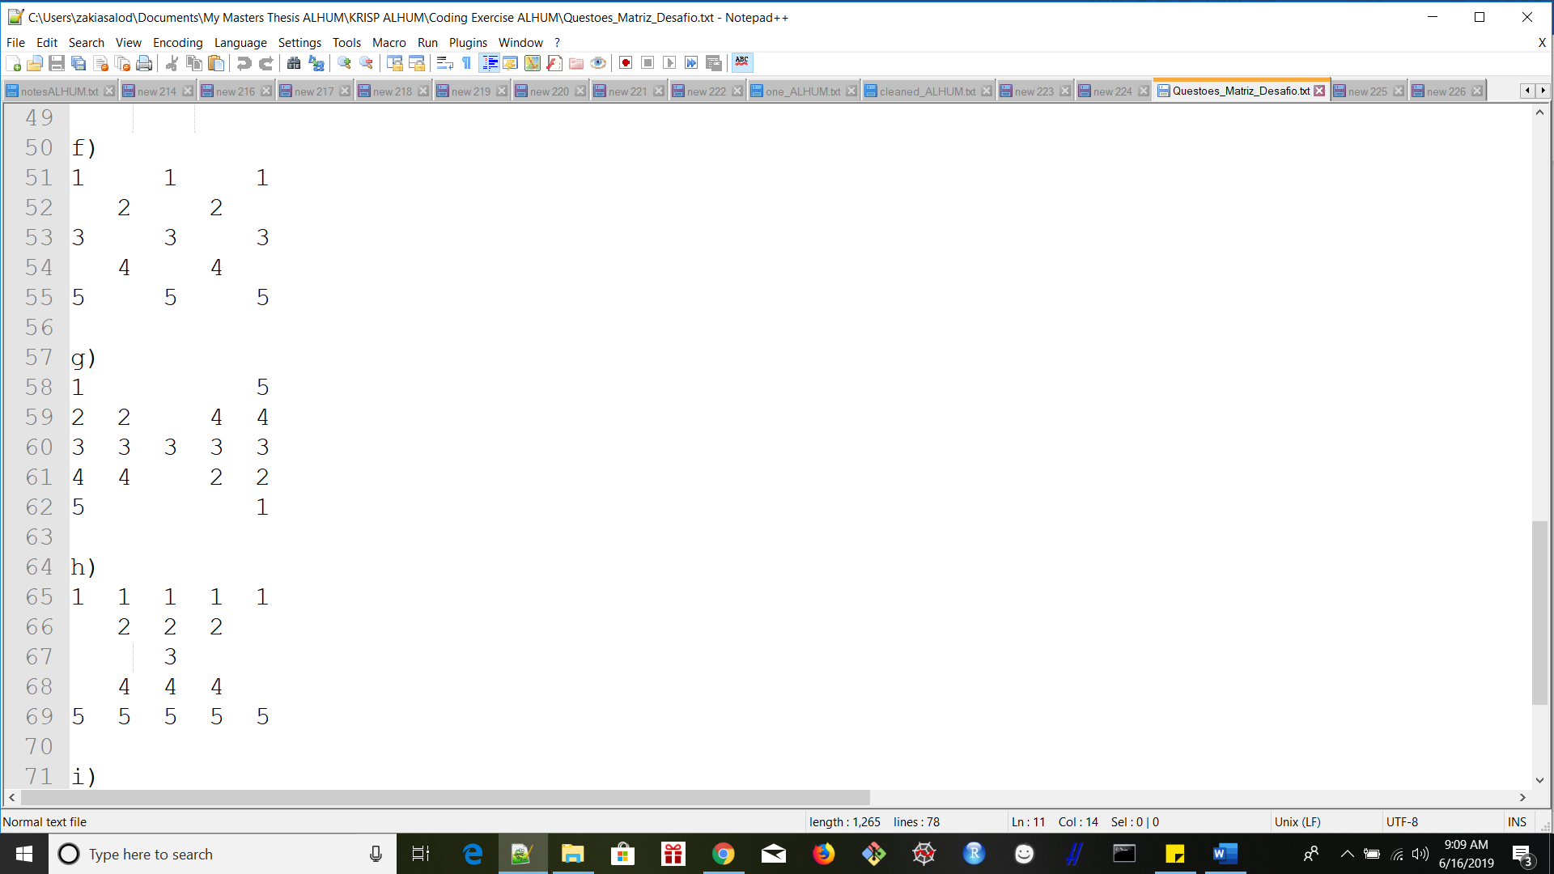

**Figure 7. Matrix pattern algorithm G)**

## Scenario #SC8

When a user enters an odd whole number, then the matrix should print as per Figure 8 below.

## Acceptance Criteria #AC8

Populate table with the acceptance criteria for the scenario.

|  |  |
| --- | --- |
| **Given** (an initial condition) | That the user accesses the KRISP matrix illustration algorithm. |
| **When** (something happens) | The user enters an odd whole number as input into the algorithm. |
| **Then** (this is the result) | The matrix should display as illustrated in Figure 8 below, for matrix pattern algorithm H). |

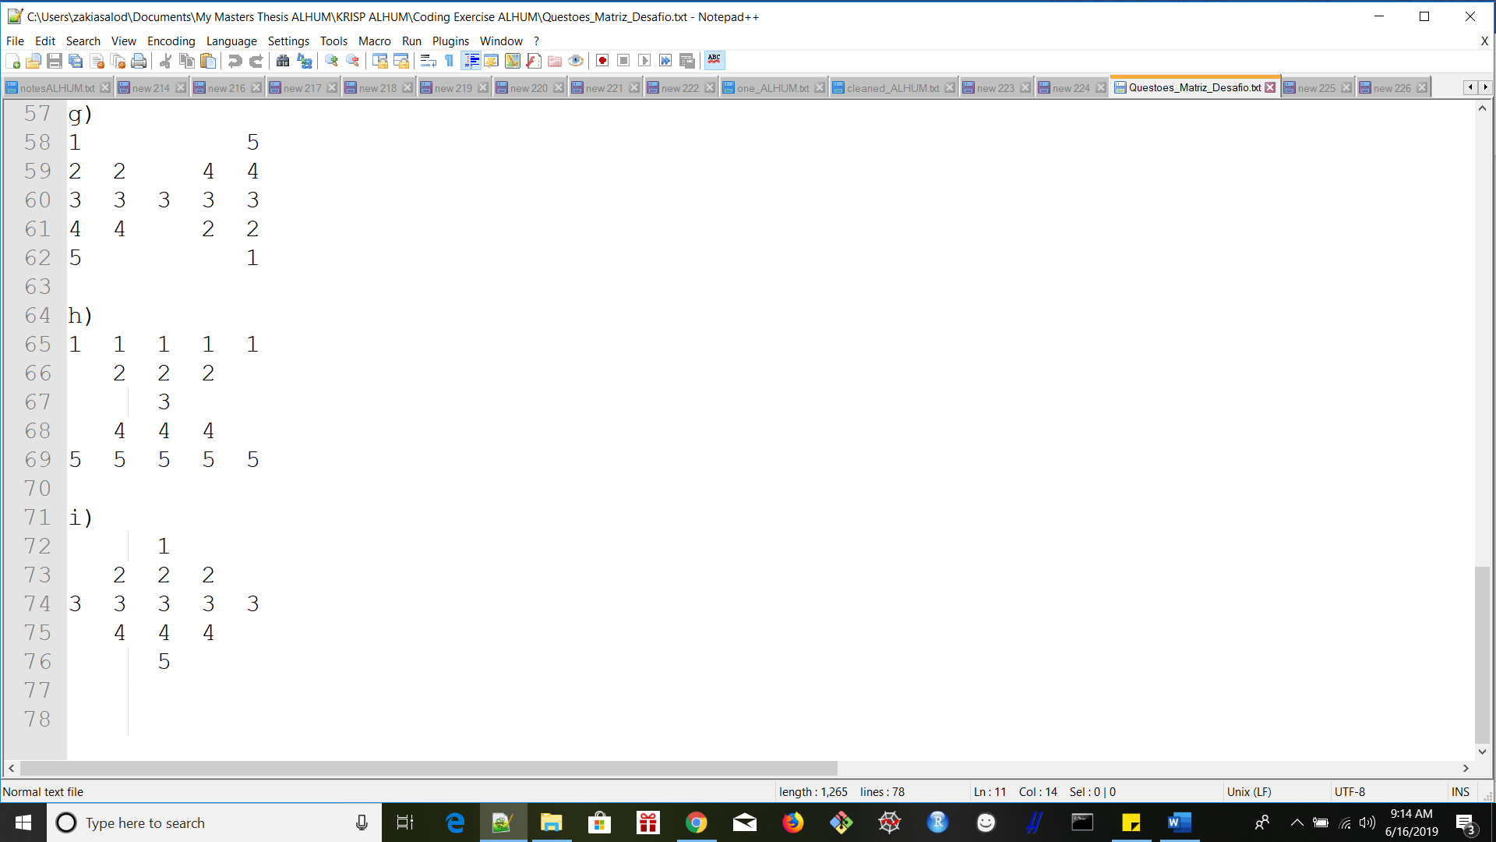

**Figure 8. Matrix pattern algorithm H)**

## Scenario #SC9

When a user enters an odd whole number, then the matrix should print as per Figure 9 below.

## Acceptance Criteria #AC9

Populate table with the acceptance criteria for the scenario.

|  |  |
| --- | --- |
| **Given** (an initial condition) | That the user accesses the KRISP matrix illustration algorithm. |
| **When** (something happens) | The user enters an odd whole number as input into the algorithm. |
| **Then** (this is the result) | The matrix should display as illustrated in Figure 9 below, for matrix pattern algorithm I). |

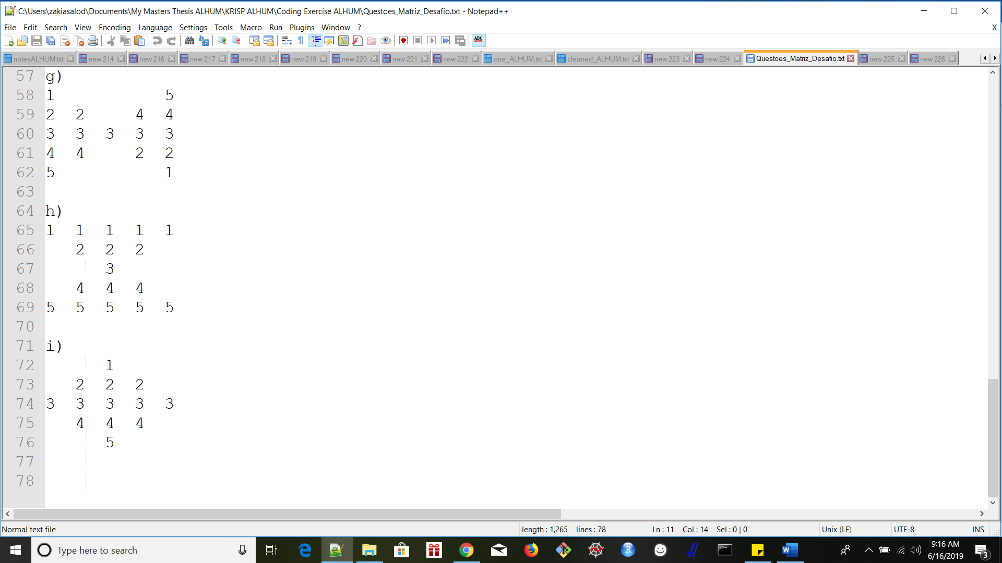

**Figure 9. Matrix pattern algorithm I)**

# Approvals

We have carefully assessed the Use Case Scenario Acceptance Criteria for this project.

MANAGEMENT CERTIFICATION - Please check the appropriate statement.

______ the document is accepted.

______ the document is accepted pending the changes noted.

______ the document is not accepted.

We fully accept the proposed matrix illustration algorithm for the purpose of displaying the matrix patterns.

(* = Required)

Zakia Salod 15/06/2019

Prepared by * DATE

Approved by * DATE

# Appendix

In this section, include all reference materials that should be considered part of this document or that add insight or value to the project (e.g., manuals, 3rd party documents, websites, books, etc.).